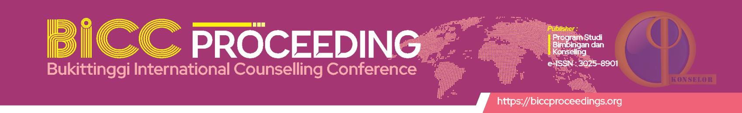

ARTICLE ACCEPTANCE LETTER

*Dear*

**Intan Sari M.Pd, Kons, Riri Okra, M.Kom , Gusnita Darmawati M.Kom, Ira Oktarini, M.Pd**

*Universitas Sjech M.Djamil Djambek Bukittinggi*

Thank you for your cooperation in performing all the changes requested by the reviewers. At the same time, we gladly inform you that your paper entitled *The Effectiveness Of Mindfulness-Based Stress Reduction (Mbsr) To Increase The Academic Resilience Of New Class X High School Students: Literature Review”*, was accepted for publication in Journal BICC Proceedings

As a result, your article/paper will be published in Volume 2, No. 33 (2024).

Thank you for: Journal BICC Proceedings Studies a vehicle for your research interests.

Bukittinggi, May 25, 2024



Proceedings coordinator

**Zahwa Aulia Siregar**