SELF-REFLECTION OF EFL TEACHERS IN FACING INDEPENDENCE CURRICULUM (A NEW CURRICULUM IMPLEMENTED IN INDONESIA)

Absharini Kardena
UIN Sjech M Djamil Djambek Bukittinggi, Indonesia

Abstract. A teacher is a key component in implementing a curriculum. The teacher is the one who works directly as a practitioner at school; the one who uses the curriculum directly for the students. Even in EFL context, a teacher is still a person who has an important role to guide the students as instructed in the curriculum. In the last eight months, Indonesia has just implemented a new curriculum, Independence curriculum. This curriculum instructs the EFL teachers to develop their own materials based on their students’ background knowledge, environmental background, and social value existing around the school. This curriculum shortly directs the teachers to play some roles that were rarely done by those teachers in previous curricula. Thus, this research analyzes teachers’ self-reflection related to their readiness to face the new curriculum. This research was conducted through mixed-method research involving 15 English teachers in West Sumatera Province, Indonesia. The data were collected through questionnaires containing self-reflections on teachers’ readiness and then supported by interviews with the teachers. The result of the research shows that most teachers argue that they lack abilities for implementing Independence curricula. It is related to their ability in conducting need analysis, creating and developing specific materials, and applying authentic assessment. It is expected that the EFL teachers might be given some training for developing their competence in facing this new curriculum

Keywords: change of curriculum; independence curriculum; self-reflection; EFL teachers

Introduction
Implementing new curriculum usually and normally faces some challenges and obstacles. The new curriculum applied in Indonesia nowadays known as Kurikulum Merdeka (Independence Curriculum). This new curriculum promotes a freedom for teachers, students and schools to decide, design and create their learning and teaching materials. In case of teachers, the teachers are giving freedom to do need analysis for analyzing and deciding what students need, lacks and wants. The teachers and schools may also decide the local wisdom which exist in their environment. Moreover, the students also get freedom to decide and propose their wants and preferences in learning.

Being able in reading is one of the goals in learning English, especially English as a foreign language. Since reading is important as a part of language skills, the students are demanded to be able to read and fully comprehend the text. In fact, some students or even the English teachers assume that reading in English means reader knows the meaning of all the words on the text. Simply, they argue that being able to read means having lots of vocabulary. In fact, reading must not always depend on vocabulary acquisition only, but it is more on understanding the content. Reading aims to get the message delivered by the writer through understanding the content of the text…..(). Besides, reading can also aim to get such pleasure. Reading for enjoyment is not something new. In short, it can be stated that reading has many aims.
As mentioned above, one of the aims in reading is understanding the text while getting enjoy of the text. Those purposes of reading can be obtained through doing extensive reading. Generally, extensive reading can be defined as a reading activity that helps students to read based on their level of reading ability. According to the British Council, extensive reading is an approach to reading in a second language that provides students with the opportunity to read longer passages of their choice and which they can read at their own level of ability. In line with the previous statement, Bambord and Richard (2004) stated that extensive reading is reading a large amount of material that is specifically designed quickly for general understanding with a special focus on meaning in the target language. The material provided in extensive reading is to provide opportunities for students to understand enough without help from outside sources. In a Second Language Learning environment; students must be exposed to large amounts of target language input, which is most successful through extensive reading (Aliponga, 2013).
Based on the explanations above, it can be simply said that extensive reading at least can give benefit for students in choosing any texts that they would like to read (Nation and Waring, 2013). In line with this theory, it can be assumed that extensive reading can be done to students at the beginner level so that they can help themselves to read the text easily and get a high motivation to read. By considering those theories, this article aims to describe students’ improvement after they get extensive reading subjects. Further, this article would also like to see how better extensive reading helps students in improving their reading motivation ad their reading ability.

Research Method
This research was conducted by using mixed-method research. The research applied sequential explanatory research in which the data of the research were collected through quantitative procedure and ten followed by qualitative procedure sequentially. The research English was Conducted on 18 English teachers who teach at junior and senior high schools in West Sumatera. Those teachers were chosen as informants of the research by using a purposive sampling technique. The respondents were chosen because they were volunteers in this research and felt free to give valid data related to the implementation of the independence curriculum. Besides, those informants were teachers who implemented this new curriculum.

The data were collected by using two instruments: an online questionnaire and interview. The questionnaire was used to gather quantitative data related to teachers’ comprehension of Independence curriculum and their reflection on their own comprehension. Furthermore, a depth interview was conducted to 4 English teachers in order to collect qualitative data on teachers’ reflection of their needs in implementing this new curriculum. All the procedures conducted in this research were done for about a month through online and/or offline meeting. The data then were analyzed by using SPPS for quantitative data and using procedure of analyzing qualitative data proposed by Miles, Huberman, and Saldana (2014). Here are the following steps in analyzing the qualitative data:

- Data Condensation or Reduction
Data condensation or reduction aimed at selecting, focusing, simplifying, abstracting and transforming raw data obtained from the field. Raw data meant were results of interviewing lecturers, interviewing students, and documents of students’ writing achievement, writing syllabus and theories. Data reduction was carried out by selecting information needed for research purpose, categorizing them, and abstracting them. Data reduction took place during this research to answer defining stage of front-end analysis, students’ analysis, task analysis, concept analysis and specifying instructional objectives.

b. Data Display
The second important component in data analysis was data display. It means a group of information was arranged to ease the process of drawing conclusion and of taking action. Data display for this research used combination of narrative text form and figure. It was created as clear and meaningful as possible, so that the researcher could see what happened and continued to next analysis display the interview result, the researcher presented in the narration by describing the data to answer the research question related to problems, needs and possible solutions to the problems faced by lecturers and students related to writing teaching conducted so far problems faced by lecturers and students in writing instruction. To present the document analysis, the researcher used graphic to indicate how many students got difficulties with writing subject or who failed to achieve good grade in order to help researcher describe students’ achievement.

c. Conclusion Drawing and Verification

The last stage was conclusion drawing and verification. Drawing conclusion was part of holistic configuration which could not be separated from the other two. During data reduction and data display, the researcher has initiated what conclusion was derived whenever this information was discarded and so on. From the presentation of interview data, the researcher could see the indication what problems related writing instruction applied so far. Based on the characteristics appeared in data display, she concludes what problems related to writing instruction, needs and possible solution to the problems that lecturers and students faced during writing teaching. Verification was also done to seek meaning from conclusion drawn. Theoretically, verification deals with generating meaning form data and confirming findings. To achieve that, there was tactic executed which worked for this research, namely doing clustering and making contrast or comparisons between those who perceived writing difficult and boring and those perceiving it challenging and exciting.

Finding and Discussion
The finding of the research is explained based on the following indicators:
 | INDICATORS OF THE RESEARCH | SUB-INDICATORS OF THE RESEARCH
1 | Teachers’ readiness in facing independence curriculum | - Teachers’ comprehension on the concept of the new curriculum  - Teachers’ self-reflection of their comprehension on the concept of the new curriculum
II | Teachers’ obstacles in implementing new curriculum | - Workshop  - Facility  - Teachers’ comprehension and ability

The finding of the research is explained as followed:
Teachers’ comprehension on the concept of the new curriculum

Teachers’ self-reflection of their comprehension on the concept of the new curriculum

Teachers’ obstacles in implementing new curriculum

Conclusion

Implementing new curriculum is normally facing such obstacles and challenges. As happened in Indonesia nowadays, implementing new curriculum namely Independence curriculum, creates such obstacle in a real implementation. The main case is on teachers’ readiness in facing and implementing this new curriculum. Teachers’ self-reflection on their competence is compared to their performance in implementing independence curriculum show a significant result. The teachers reflect and argue that they felt ready to apply this new curriculum. Meanwhile, based on the result of the research, they still need more training and workshop for improving their knowledge and their competence in order to implement independent curriculum. This gap shows that the crucial element in implementing new curriculum is not only on providing any trainings for the teachers, but also guaranteeing that the teachers have a real competence to implement it. All sides in educational sector needs to differentiate between teachers’ opinion of their readiness and their real competence and readiness in implementing independence curriculum. Thus, it is suggested for every sides of educational parties to pay attention on this point.

Triangulation <Second-level Headings, Times New Roman 13, Bold, Title-Case, Double-Line Space Before Text>

<Times New Roman 12, indent first line 1cm, do not double-space between paragraphs, double-line space before next section heading or text>

Student Population<Third-level headings, times new roman 12, bold, sentence case, indent 1, no line space before new text (which is indented as above)>
Sentence text <Times New Roman 12, indent first line 1cm, do not double-space between paragraphs, double-space before next section heading or text>

This is a long quote of 40 or more words. Indent left 1cm and 0.5cm right. Use times new roman 11, with 1 blank line before this text and one blank line following. If a citation follows, include the citation within the sentence structure of the quote, or else place the citation in the text before the long quote (Jones & Smith, 2023, p. 13).

Table 1. Facebook Poll <Times New Roam 12, Title Case>
Question: What are the 3 most important services a teacher association should provide members/society? Tick no more than three, please. (This is part of a research project, I appreciate your inputs [sic]).
Response Items | Number of  Respondents | Percentage of  Responses
Workshops (local) | 44 | 31.4
Conferences/seminars/symposia | 32 | 22.9
Ideas sharing / mentoring | 30 | 21.4
Professional/scholarly publications | 13 | 9.3
Socialization | 8 | 5.7
Advocacy for relevant public policy | 6 | 4.3
Labor representation (union) | 4 | 2.9
Discounts in services beyond the society itself (bookstores, etc.) | 2 | 1.4
Vetted work opportunities | 1 | 0.7
Total Responses | 140 | 100
Note. Respondents = 56.

Figure 1. Korean Vowel Positioning <Times New Roman 12, Bold>
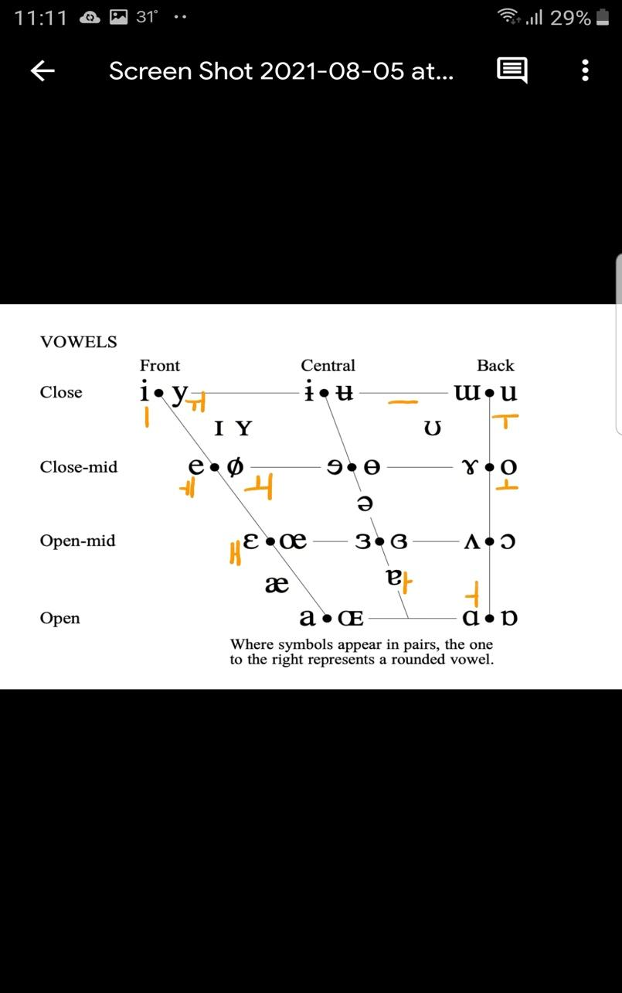

(Figures should be
Readable!)

Note. Adapted from IPA (2020). <”Note” is bold, italics. Text is neither bold nor italics, sentence-case, all times new roam 10>

Acknowledgements <Times New Roman 12, “Small-Caps,” Bold>

The author acknowledges (Non-authors (colleagues, friends, supervisor, etc.); Funding sources; Editing services, Administrative staff; Study registration; Data sharing, Any disclaimers). <Times new roman 11, sentence case, no indent>

The Authors <Times New Roman 12, “Small-Caps,” Bold>

James R Jones teaches at... Email: JRJ@mail.com, ORCID: <Times new roman 11, sentence case, no indent – name is bolded. Email optional, ORCID optional.>

William C Smith is a researcher at… Email: WCSmith@university.edu, ORCID <Times new roman 11, sentence case, no indent – name is bolded. Email optional, ORCID optional.>

Authors’ Contributions <Times New Roman 12, “Small-Caps,” Double-Line Space before Text>

JRJ – Conceptualization, Research Design, Data Collection, Data Analysis & Evaluation, Manuscript Writing <Times new roman 11, sentence case, no indent>

WCS – Statistical Analysis, Evaluation. <Times new roman 11, sentence case, no indent>

Authors’ Note <Times New Roman 12, “Small-Caps,” Double-Line Space before Text>

All authors declare that they have no conflicts of interest. The authors… <Times new roman 11, sentence case, no indent>

References <Times New Roman 12, “Small-Caps,” Double-Line Space Before Text>

Aubrey, J., & Coombe, C. (2010). The TESOL Arabia conference and its role in the professional development of teachers at institutions of higher education in the United Arab Emirates. Academic Leadership Journal, 8(3). https://scholars.fhsu.edu/alj/vol8/iss3/53/
<Times new roman 11, “hanging indent” 1cm, activate hyperlinks, right margin NOT justified (ragged), references in APA style!>

